A. Prabhu Kumar

191911501

12. Demonstrate Infrastructure as a Service (IaaS) by creating a resources group using a Public Cloud Service Provider (Azure), configure with minimum CPU, RAM, and Storage.

Step: 1

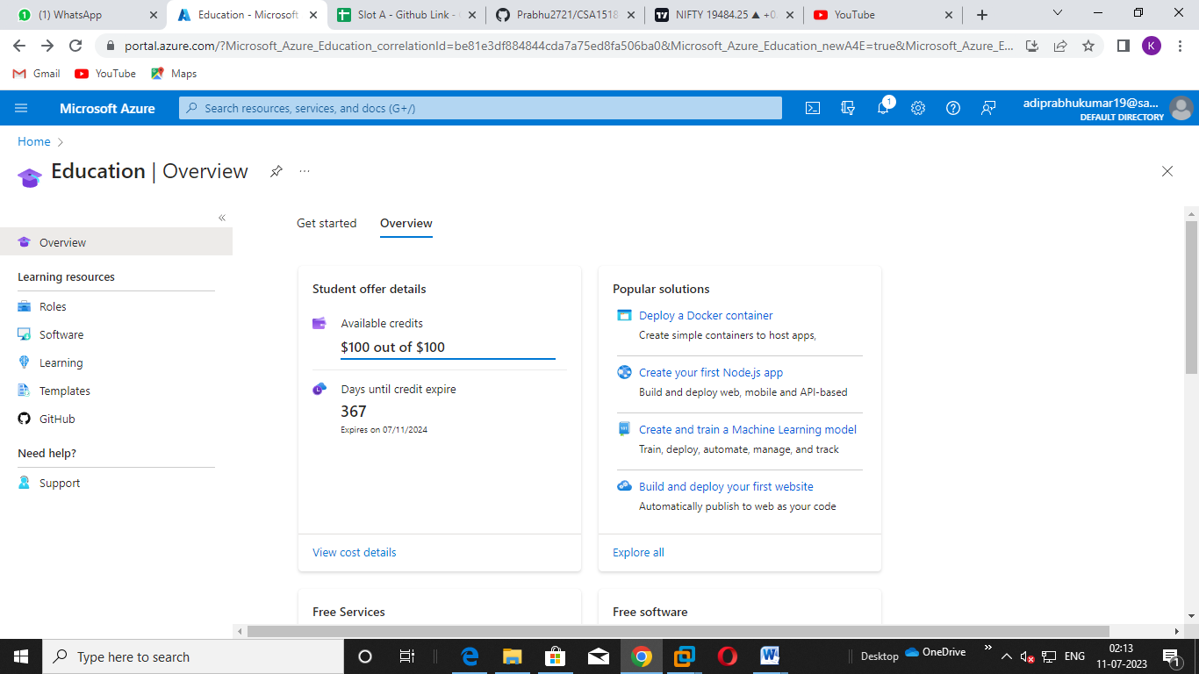

Step: 2

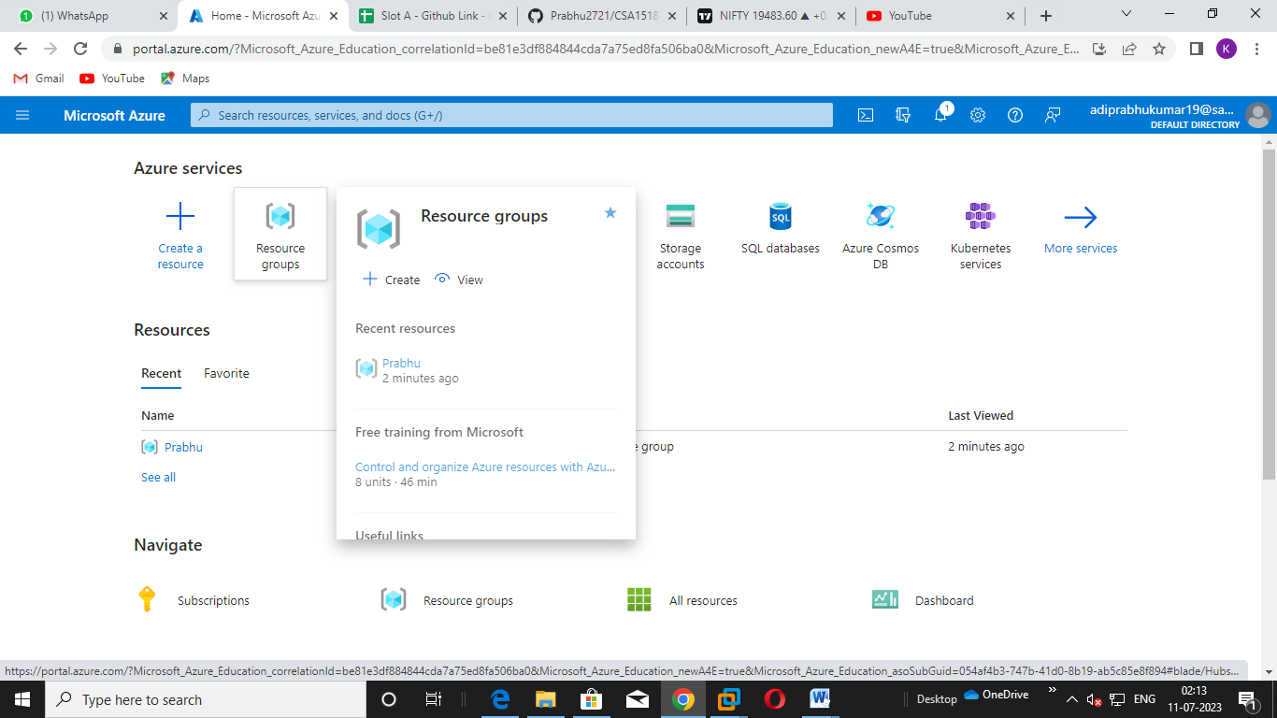

Step: 3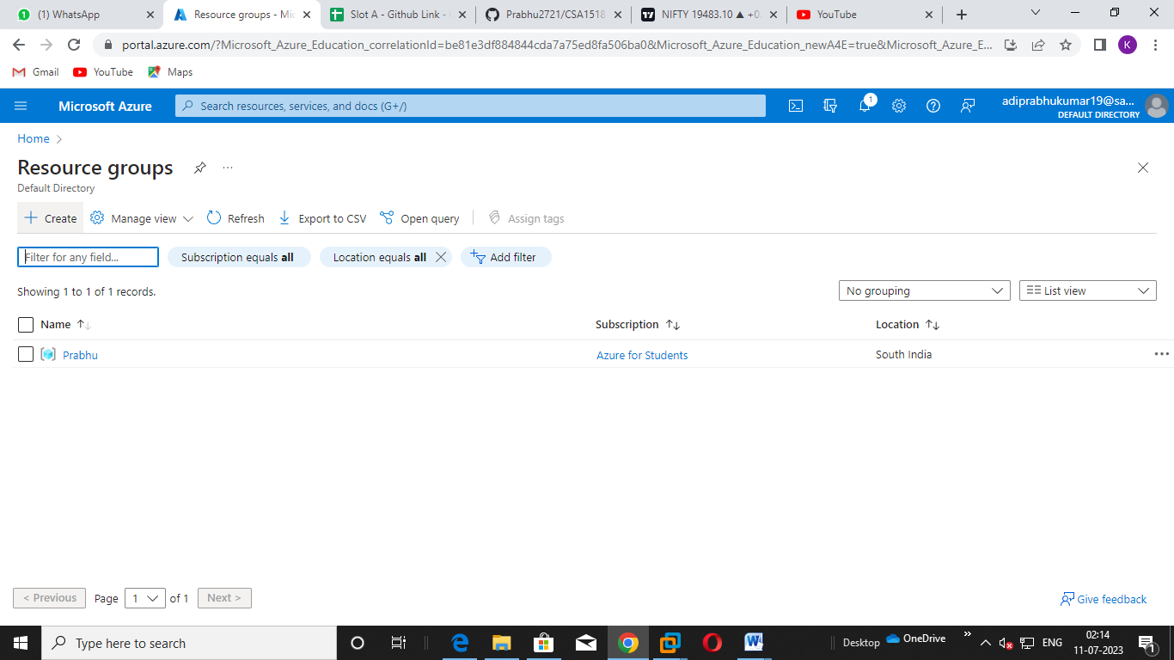

Step: 4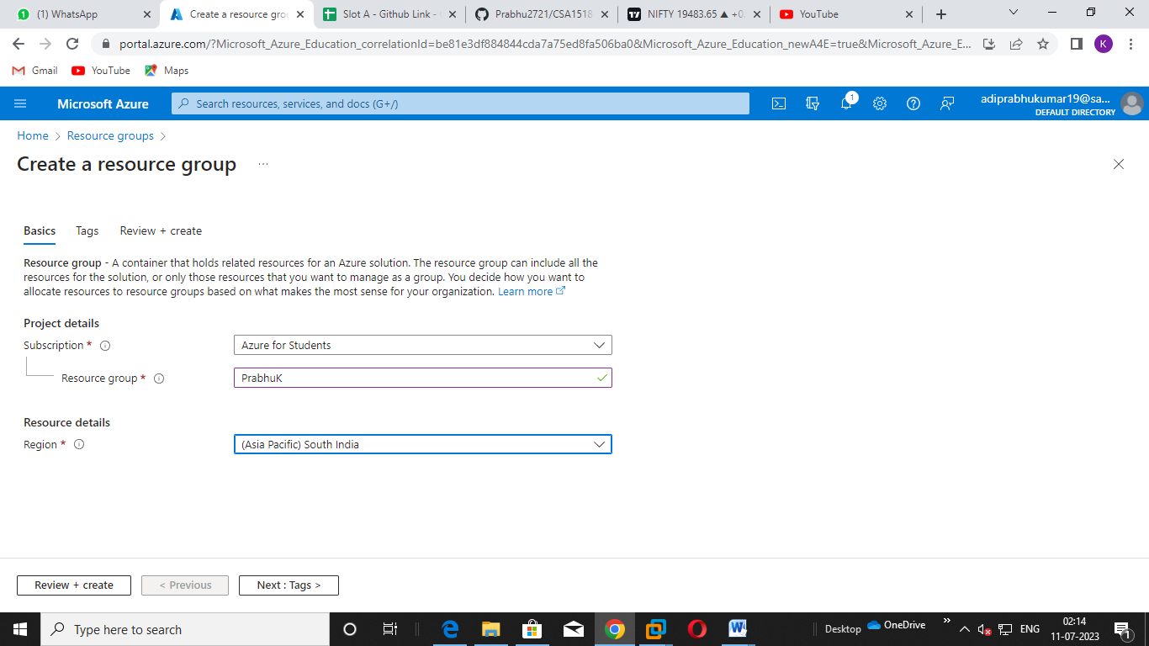

Step: 5

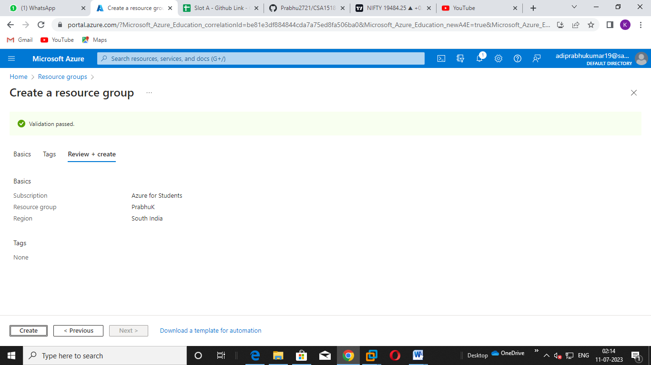

Step: 6

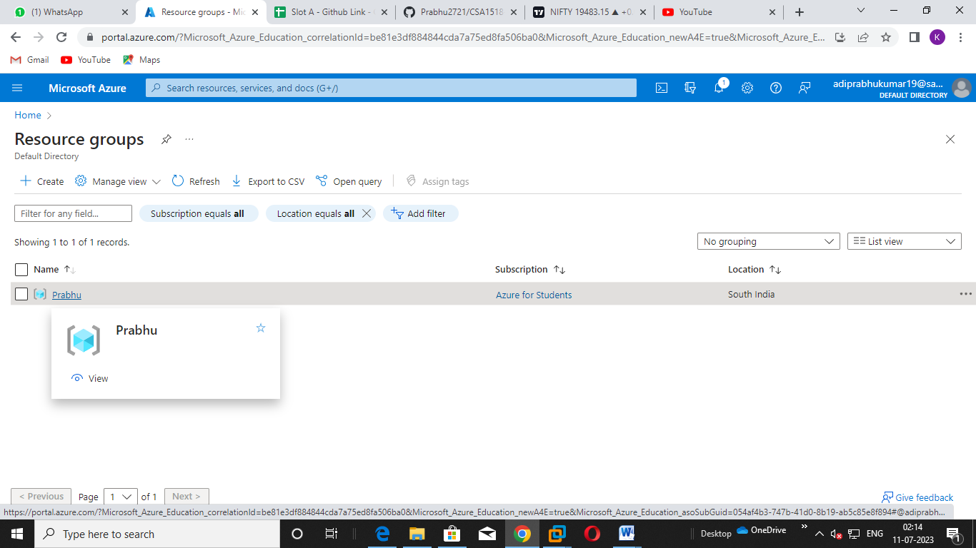

Step: 7